**NEXUS Installation Implementation**

**(8.0.1)**

**Installation Guide & Documentation**

Approval

| Signatures by each signatory indicate their acceptance that this document is complete and accurate to the best of his/her knowledge per responsibilities outlined in this document and as guided by approved methodologies and established procedures. | | |
| --- | --- | --- |
| Talend Lead:  Artha Emp | **Subhransu** | **Date:** |
| Project Manager:  Artha Emp | **Pavan Valluri** | **Date:** |
| Talend Developer:  Artha Emp | **Omkar Patil** | **Date:** |

**Download & Configure Java**

cd /usr/lib

mkdir jvm

Give full permission to jvm folder

wget https://www.oracle.com/in/java/technologies/javase/jdk11-archive-downloads.html#license-lightbox

(or)

#Extract the java file

tar -xvf jdk-11.0.17-linux-x64.tar.gz

#set the java path

export JAVA_HOME=/usr/lib/jvm/jdk-11.0.18

export PATH=$JAVA_HOME/bin:$JRE_HOME/bin:$PATH

#reboot or restart the server to check java version

java –version

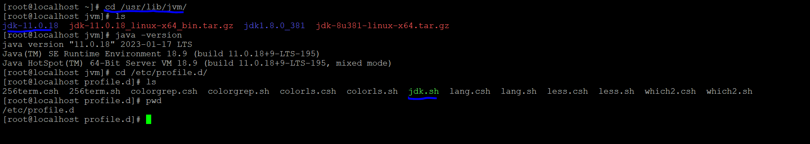

#To Run Nexus on Java 11 always use SonatypeNexus version

Talend Support. As per our 8.0.1 doc, we support 3.30 to 3.53 in 8.0.1.

Always Download SonatypeNexus version between 3.30 to 3.60

<https://help.talend.com/r/en-US/8.0/installation-guide-windows/compatible-artifact-repository-versions>

# mkdir nexus

cd nexus

yum install wget

#copy the Download link

wget https://download.sonatype.com/nexus/3/nexus-3.35.0-02-unix.tar.gz

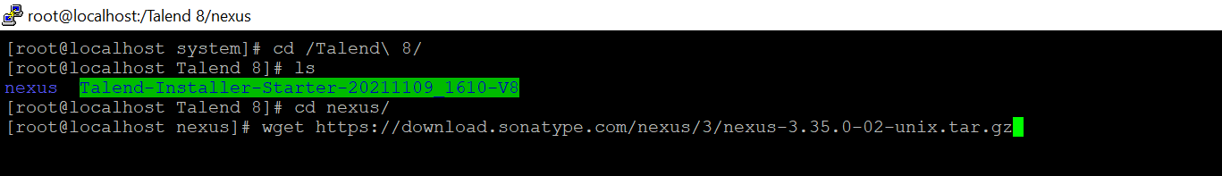

#Extract the downloaded file

tar –xvzf nexus-3.35.0-02-unix.tar.gz

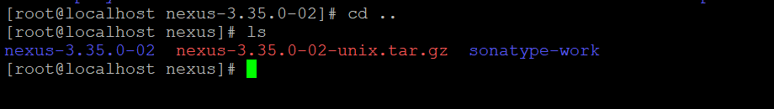

cd nexus-3.35.0-02

cd bin

*Run this command

nohup ./nexus run &

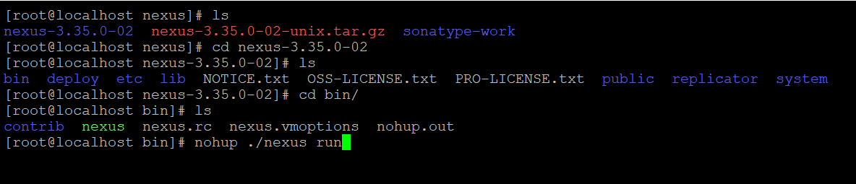

#Check the nexus running on server

http://{ip_addresss}:8081

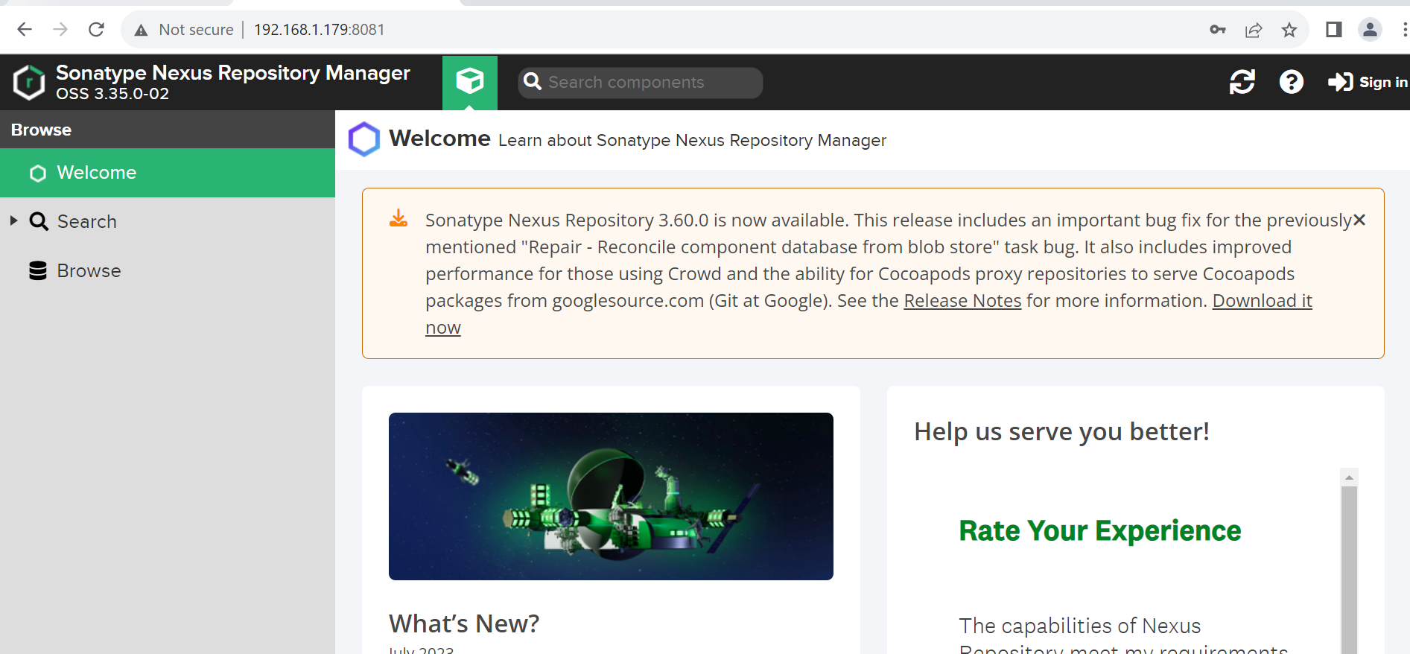

# Sign in to the nexus

User :- admin

Password:

cd /sonatype-work/nexus3

cat admin.password

#copy and paste the password



#Nexus configuration

*Configuring the Nexus

* Check the nexus should be up and running.
* Go to the Sonatype Nexus Repository Manager interface.
* Go to the **Repositories** tab to create the following repositories:

1. talend-updates
2. talend-custom-libs-snapshot
3. talend-custom-libs-release

a) Click **Create repository**.

* Select **maven2 (hosted)** from the list.
* Name your repository **talend-updates**.
* Under the sub-section **version policy**, select **Release**.
* Click **Create repository** to save your changes.

b) Create another **maven2 (hosted)** repository named **talend-custom-libs-snapshot**

* Under the sub-section **version policy**, select **snapshot**
* Click **Create repository** to save your changes.

c) Create the last maven2 (hosted) repository and name it talend-custom-libs-release**.**

* Under the sub-section **version policy**, select **Release**.
* Click **Create repository** to save your changes.

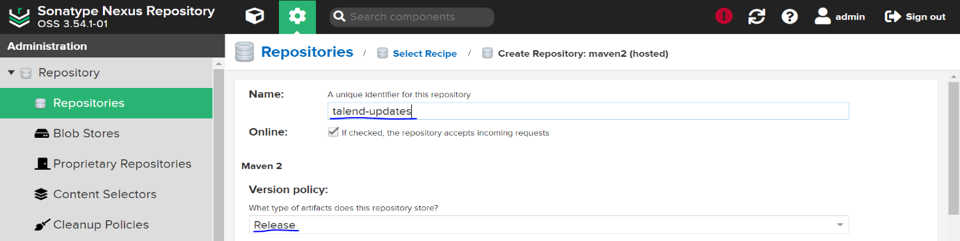

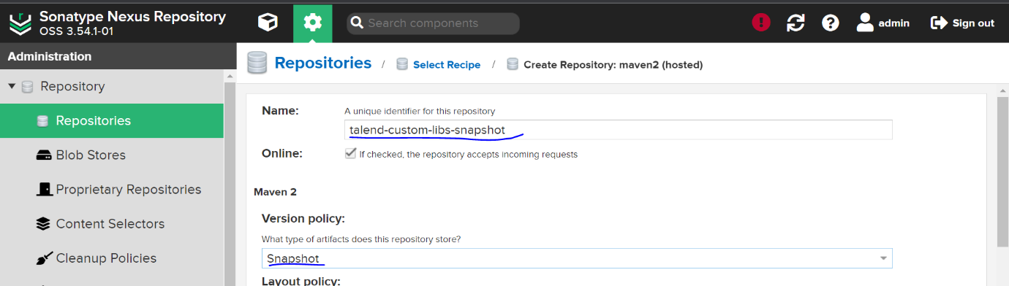

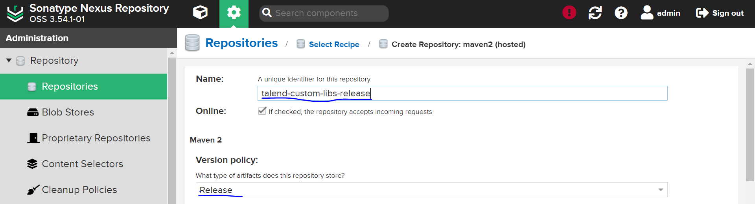

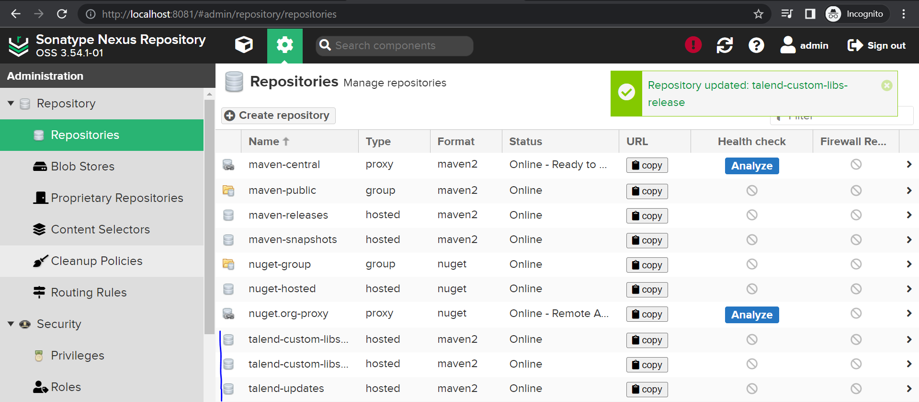

# Go to the **Roles** tab, click **Create role** > **Nexus role** and create the following roles with the following privileges added to the **Given** list:

ROLE ID: - **talend-updates-admin**

PRIVILAGES: -

* nx-repository-view-maven2-talend-updates-add
* nx-repository-view-maven2-talend-updates-browse
* nx-repository-view-maven2-talend-updates-edit
* nx-repository-view-maven2-talend-updates-read
* nx-script-*-run

ROLE ID: - **talend-updates-read-only**

PRIVILAGES: -

* nx-repository-view-maven2-talend-updates-read
* nx-repository-view-maven2-talend-updates-browse
* nx-script-*-run

ROLE ID: -**talend-custom-libs-admin**

PRIVILAGES: -

* nx-repository-view-maven2-talend-custom-libs-release-add
* nx-repository-view-maven2-talend-custom-libs-release-browse
* nx-repository-view-maven2-talend-custom-libs-release-edit
* nx-repository-view-maven2-talend-custom-libs-release-read
* nx-repository-view-maven2-talend-custom-libs-snapshot-add
* nx-repository-view-maven2-talend-custom-libs-snapshot- browse
* nx-repository-view-maven2-talend-custom-libs-snapshot-edit
* nx-repository-view-maven2-talend-custom-libs-snapshot-read
* nx-script-*-run

ROLE ID: - **talend-custom-libs-snapshot-read-only**

PRIVILAGES: -

* nx-repository-view-maven2-talend-custom-libs-snapshot-browse
* nx-repository-view-maven2-talend-custom-libs-snapshot-read
* nx-script-*-run

ROLE ID: - **talend-custom-libs-release-read-only**

PRIVILAGES: -

* nx-repository-view-maven2-talend-custom-libs-release-browse
* nx-repository-view-maven2-talend-custom-libs-release-read
* nx-script-*-run

#Add the roles in the roles and privileges in the roles subsection

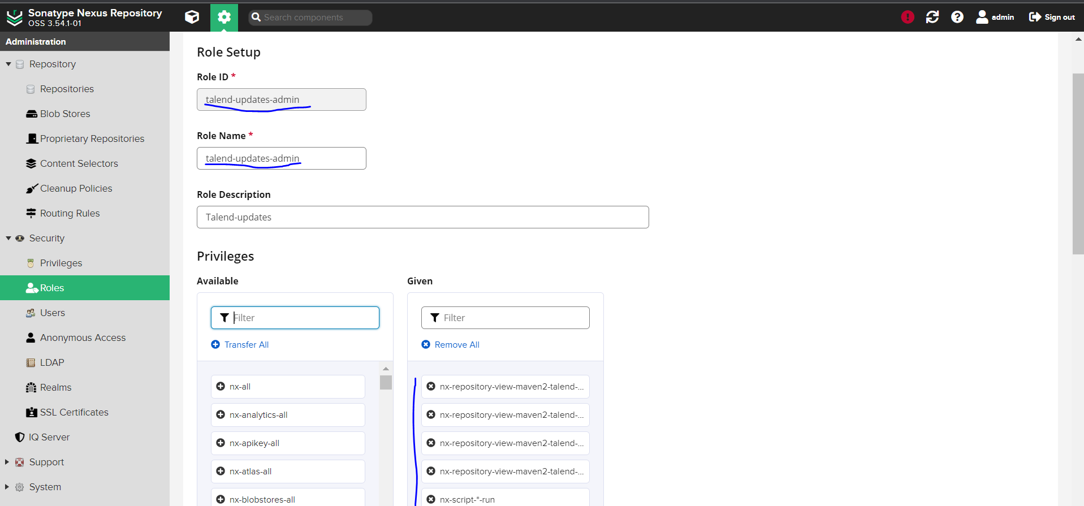

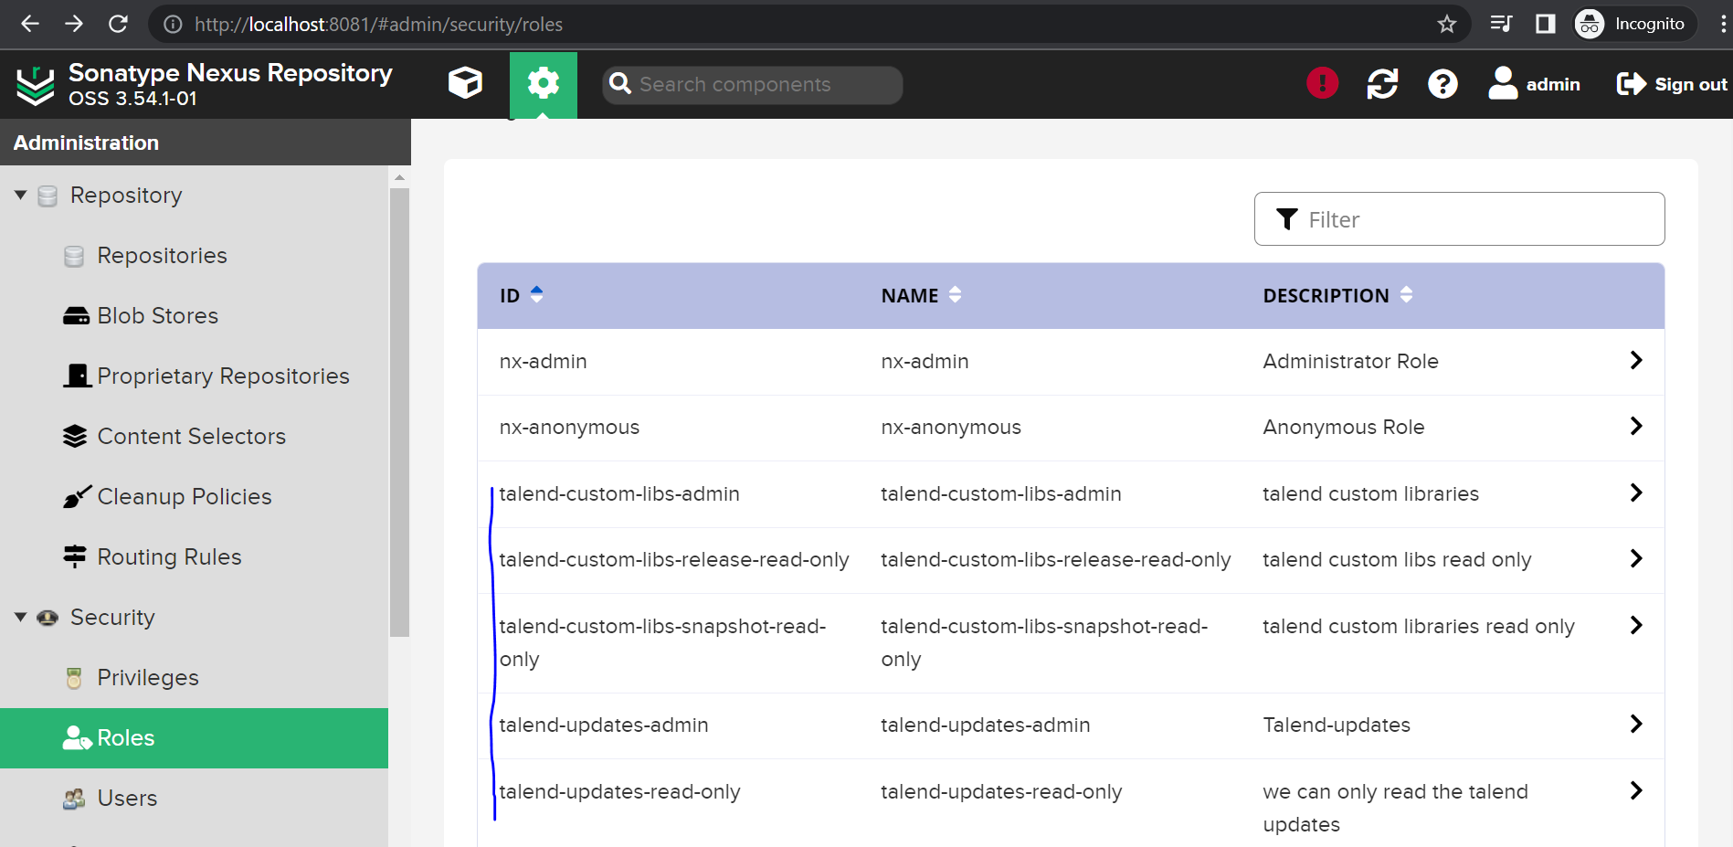

# Under the **Users** tab, create the following users:

a) talend-updates-admin:

This user is used in Talend Administration Center **Configuration** > **Software Update** group. Talend Administration Center downloads the patch from Talend Update Server and uses this account to upload the patch to Nexus. Talend Studio can download the patch from Nexus without credentials.

b) talend-custom-libs-admin:

This user is used in Talend Administration Center **Configuration** > **User Libraries** group. Talend Studio gets the configuration information from Talend Administration Center to upload and download third-party libraries.

* Click **Create local user**.
* Write **talend-updates-admin** as the ID and fill the other required fields.
* Go to the **Roles** sub-section and add **talend-updates-admin** to the **Granted** list.
* Click **Create local user**.
* Create the user with the **talend-custom-libs-admin** ID.
* Go to the **Roles** sub-section and add **talend-custom-libs-admin** to the **Granted** list.
* Open the **admin** user.
* Add the **nx-admin** role to the **Granted** list.
* Open the **anonymous** user.
* Add the **nx-anonymous**, **talend-custom-libs-release-read-only**, **talend-custom-libs-snapshot-read-only** and **talend-updates-read-only** roles to the **Granted** list.

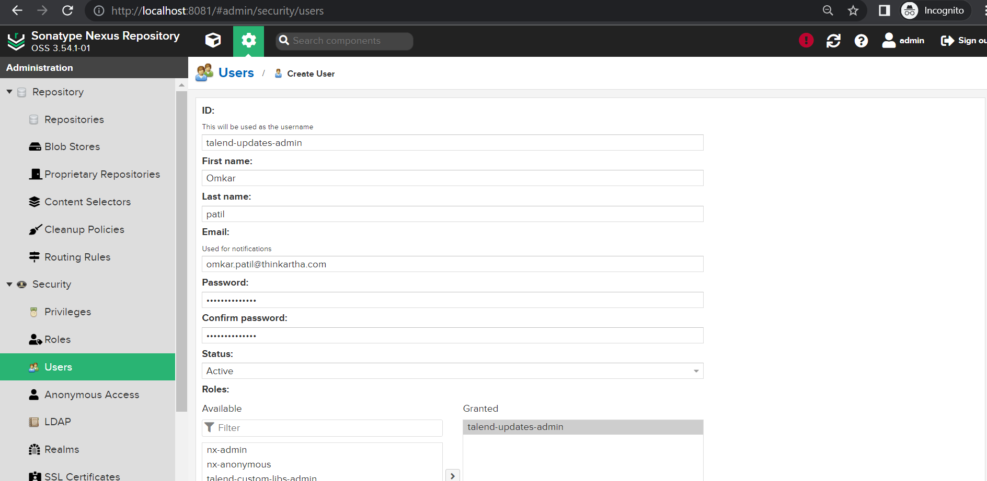

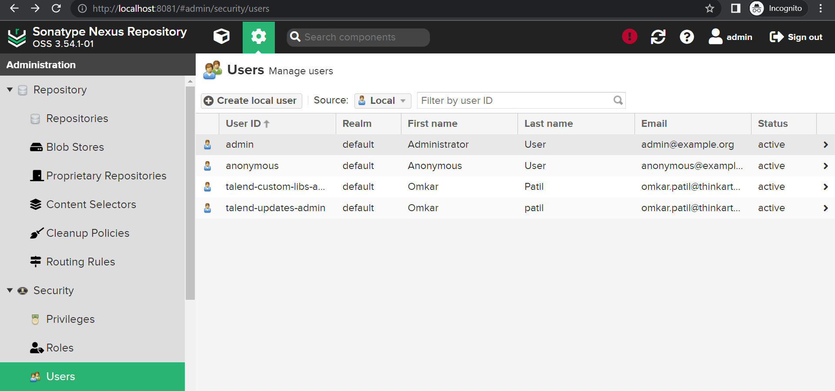

# Deploy a sample job in Nexus by using Talend Studio

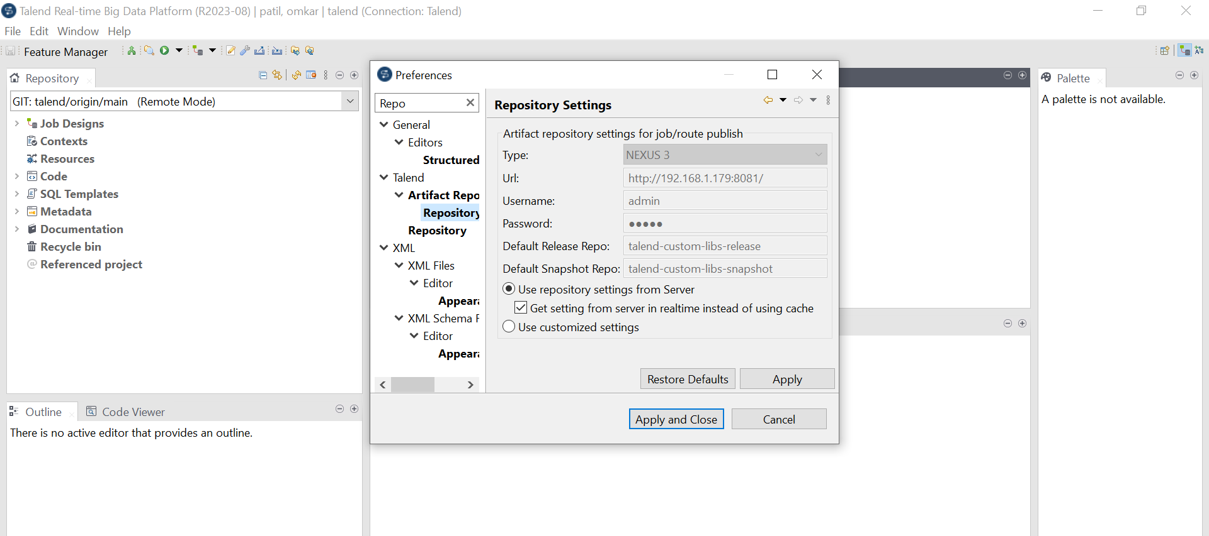

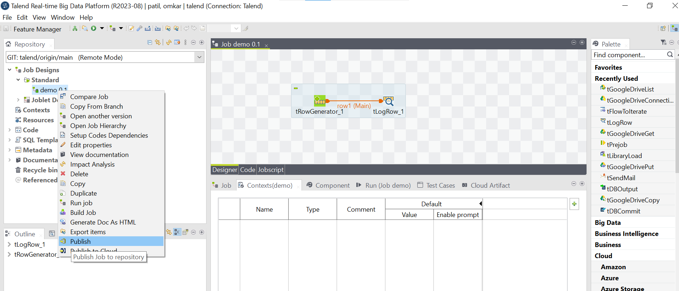

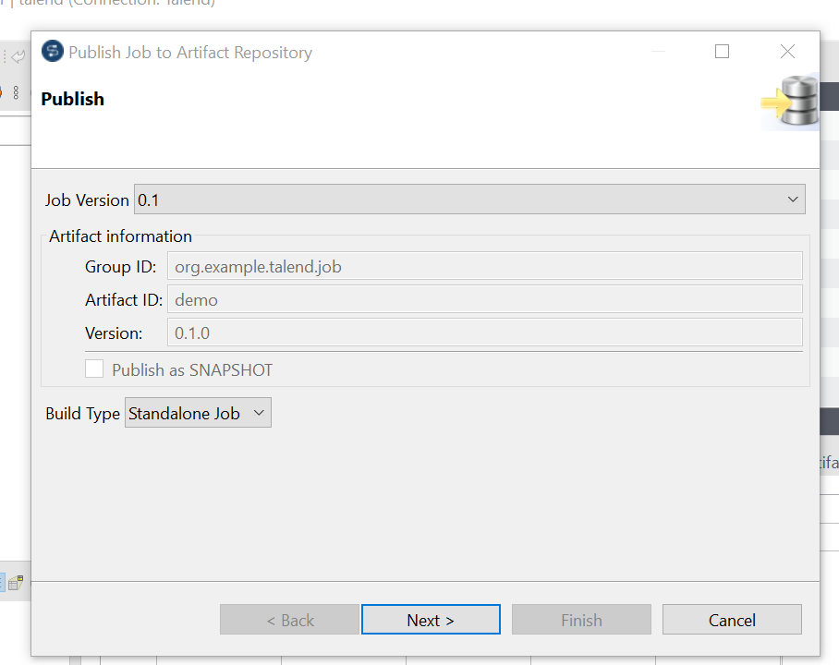

# Published job in Nexus

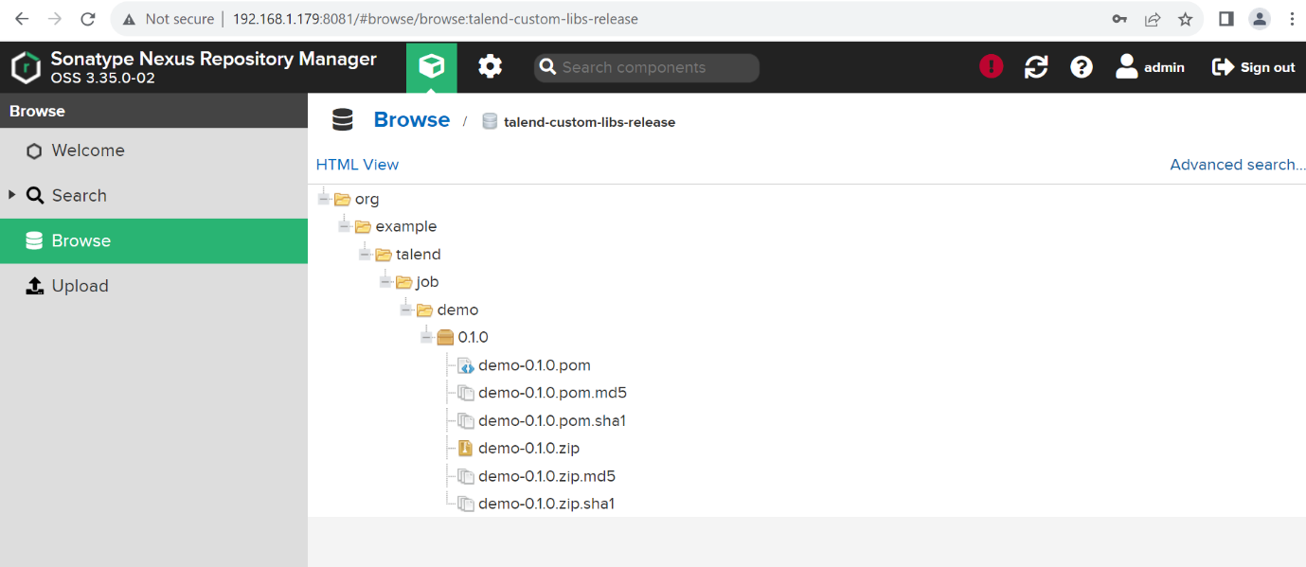

# Deploy job in TAC using Nexus

